Assembly Instruction

- Firstly, set up the stand.

Plastic stands: Carefully insert the (A) into (B). Make sure the (A) is firmly inserted into the (B). And insert the other components into corresponding holes.

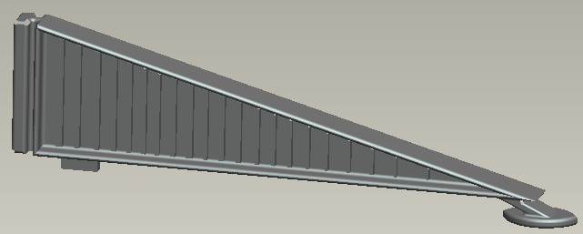
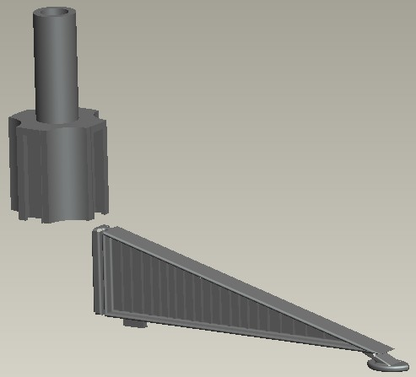
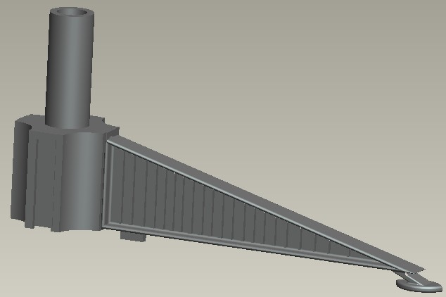
A

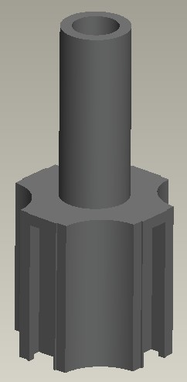
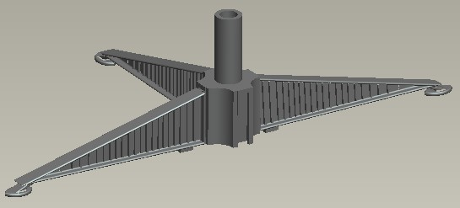
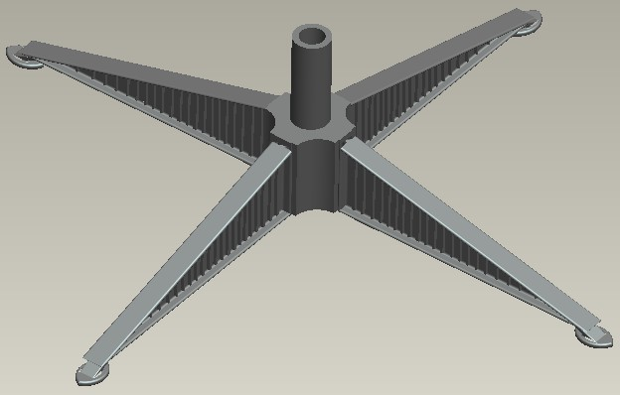
B

Iron Stand: Open the stand as follows:
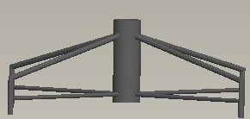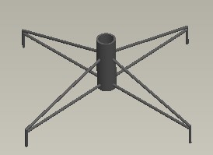

- Insert the lowest part of the stem into the stand hole, then the middle part into the lowest part, then the tree top into the middle part.
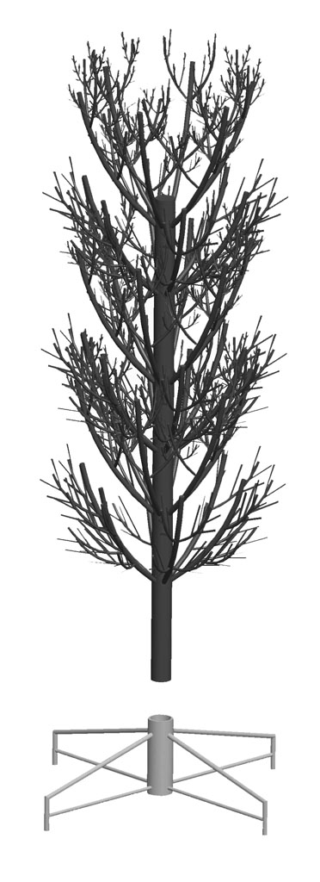
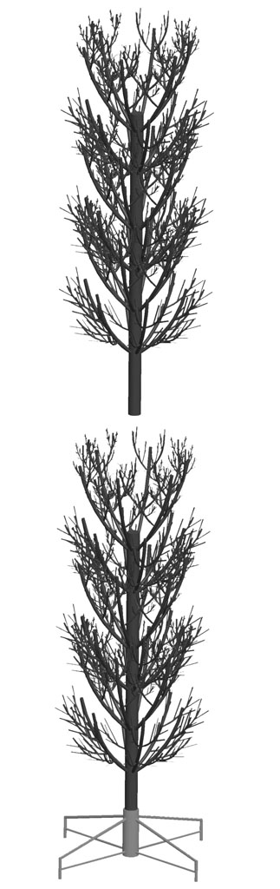
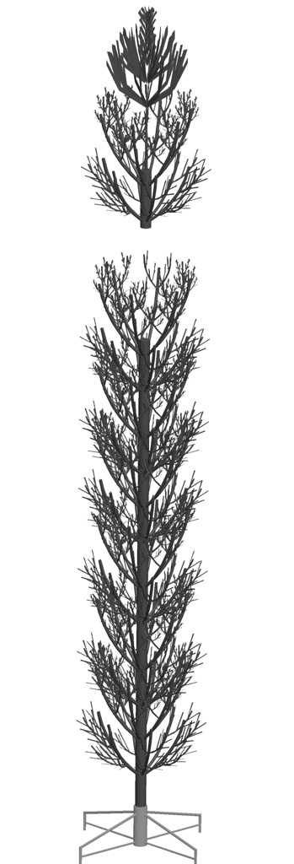
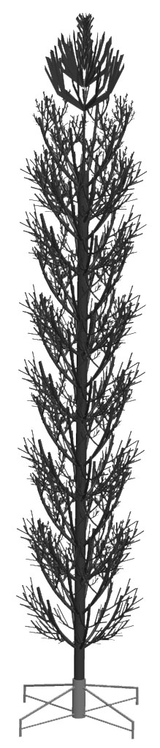
The middle part
Tree top
The lowest part

Stand hole
- Bend down the branches from the bottom to the top.
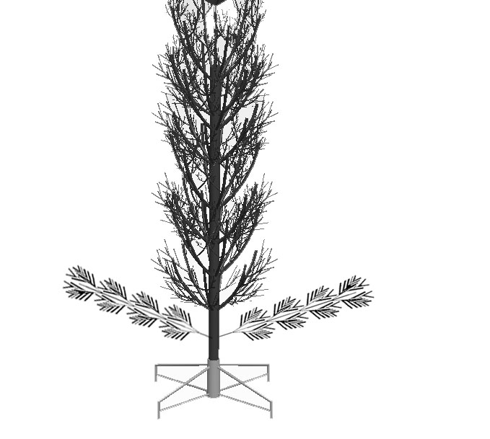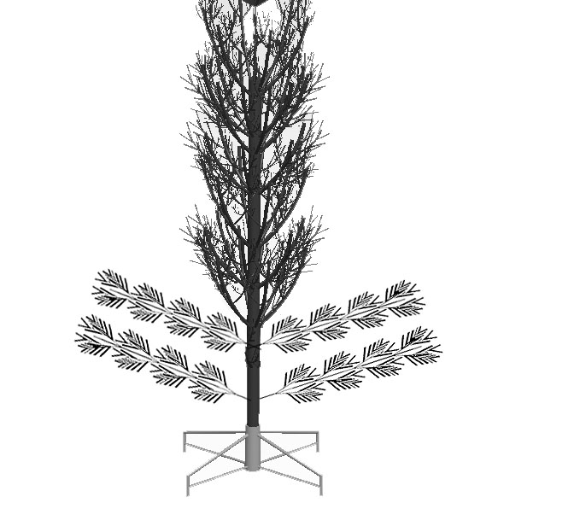

- Shape the branches starting with tips farthest from the pole, cross to open the tips.

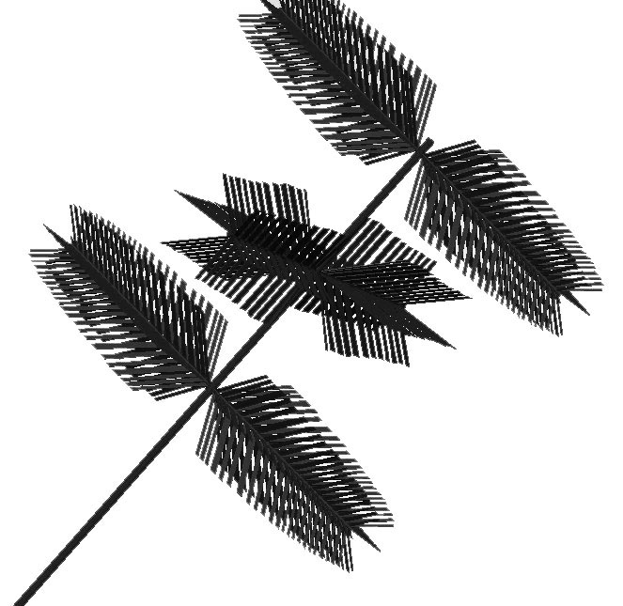
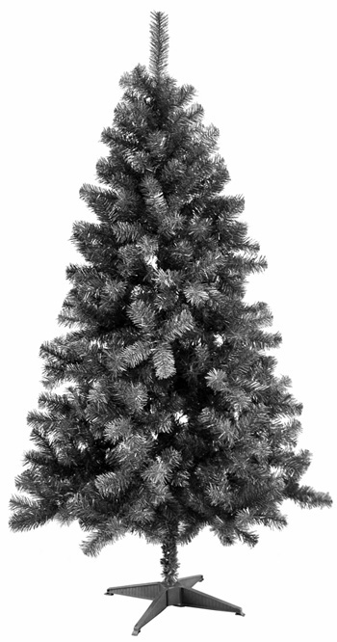

- After shaping the whole tree, slightly upsweep
all branch tips for a uniform look.

